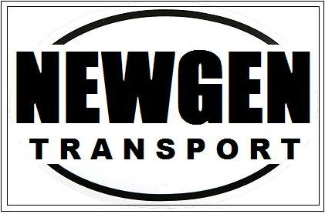

Dear Valued Customer,
Merry Christmas and Happy New Year! As the New Year is approaching us we’d like to take this chance to wish you all another great year and many thanks for choosing us as your dedicated transport company.
We will be implementing the famous the toll bridge fee as of January 1st, 2014. As we’ve all already accustomed ourselves to this new bridge, it doesn’t matter who crosses it the government will charge for it (no exceptions even for couriers). The basis on how this toll fee is charged is based on the fastest route from point A to B requiring the crossing of the Port Mann. We propose a $15 fee to cover the expenses in crossing this bridge and in order to ensure our customer satisfaction and speedy service to you and to your team, we ask for your support one more time and we hope to see another great year in 2014 together!

Best Regards,
Michael Lee
NewGen Transport Inc.
2224 Ferndale Street,
Vancouver, BC
V5L 1Y5
Phone: 604-715-2966
Fax: 604-757-9544
Email: info.newgentransport.ca
Website: www.newgentransport.ca

